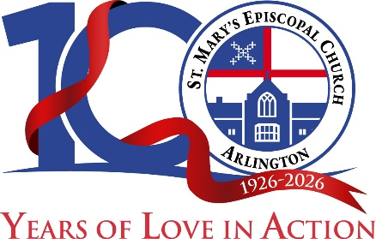
Outreach Ministry
St. Mary’s Episcopal Church
2609 North Glebe Road
Arlington, Virginia 22207
Phone: (703) 814-3354
Email: outreach@stmarysarlington.org

2026 Outreach Grant Application
Please be aware that the application submission deadlines are May 15 and October 15.
Please submit a recent Annual Report with this application
Date of Application:
Name of Ministry/Organization:
City, State & Zip Code:
PO Box Address (if used for receiving checks):
Telephone:
Mobile:
Email:
Contact Person:
Website address:

Funding Guidelines: St. Mary’s Outreach Committee focuses our parish community giving around three broad funding guidelines: relationships, need, and impact. We encourage you to respond prayerfully to each of the funding guidelines as highlighted below. Concise answers to these questions are preferred, and they could include lists or bullet points (with the indicated word limits). Please follow the suggested guidelines for each question.

Mission and Impact
- Please describe the overall mission of your Ministry/Organization (25 words or less)

- Does your organization serve people internationally, nationally, regionally, and/or locally? Please elaborate. (25 words or less)

- Please share some recent accomplishments that illustrate ways in which you have fulfilled your mission. (50 words or less)

- How will your Ministry/Organization use the support you are requesting of St. Mary’s to fulfill your mission/vision? Please be specific and describe either the project to be funded or ways in which the benefit is clearly defined and measurable. (75 words or less)

- What is your organization’s vision for the year of this application? If the funding would support systemic change, please elaborate. (50 words or less)

Relationship

- Describe how partnering with St. Mary’s as a Christian faith community informs or advances your own ministry/mission. (25 words or less.)

- Has your Ministry/Organization received financial support from St. Mary’s in the past? If yes, please share when and how your stated objectives were accomplished? (75 words or less.)

- If St. Mary’s clergy, staff, parishioners or youth are involved with your organization, please share their names and describe their roles. (50 words or less.)

- Please describe other ways, in addition to financial support, that St. Mary’s might support your organization, i.e., volunteerism, youth opportunities, internships. (50 words or less)

Need

- What was your organization’s overall budget during the prior Fiscal or Calendar Year?

- What is your planned/estimated Budget for the year of this application?

- What are other sources of your funding? This could include local, state, and federal government funding, as well as philanthropic giving. Please list other religious institutions that support your organization, including the dollar amounts or percentage of contributions.

- Is your organization a member of the Arlington Safety Net?

- What percentage of your annual budget is spent on administrative costs?

- Does your organization have a charity rating, such as Charity Navigator? If so, what is it and which entity provided it (add a link if available)?

Note to Applicant: Outreach grants from St. Mary’s are based on the church's annual financial resources.

Please indicate the level of financial support you are requesting: $____________

On behalf of the parishioners of St. Mary’s Episcopal Church,
Thank you, and God bless you!

Please submit your application to St. Mary’s Outreach Chair by emailing it and any attachments you believe to be important to katemuth@comcast.net.

You will be notified of funding decisions after the Outreach Committee deliberation and, ultimately, our Vestry’s decision. The review process can take up to three months.

Please note, St. Mary’s needs a report on how your organization has used previous grant funds before recommending additional funding.

